**Week 4 Homework Submission File: Linux Systems Administration**

**Step 1: Ensure/Double Check Permissions on Sensitive Files**

1. Permissions on /etc/shadow should allow only root read and write access.  
     
   * Command to inspect permissions: ls -l /etc/shadow
   * Command to set permissions (if needed): n/a
2. Permissions on /etc/gshadow should allow only root read and write access.  
     
   * Command to inspect permissions: ls -l /etc/gshadow
   * Command to set permissions (if needed): sudo chmod u=rw,g=,o= /etc/gshadow
3. Permissions on /etc/group should allow root read and write access, and allow everyone else read access only.  
     
   * Command to inspect permissions:ls -l /etc/group
   * Command to set permissions (if needed): sudo chmod u=rw,g=r,o=r /etc/group
4. Permissions on /etc/passwd should allow root read and write access, and allow everyone else read access only.  
     
   * Command to inspect permissions:ls -l /etc/passwd
   * Command to set permissions (if needed): n/a

**Step 2: Create User Accounts**

1. Add user accounts for sam, joe, amy, sara, and admin.  
     
   * Command to add each user account (include all five users):
     1. sudo adduser sam
     2. sudo adduser joe
     3. sudo adduser amy
     4. sudo adduser sara
     5. sudo adduser admin
2. Ensure that only the admin has general sudo access.  
     
   * Command to add admin to the sudo group: sudo usermod -aG sudo admin

**Step 3: Create User Group and Collaborative Folder**

1. Add an engineers group to the system.  
     
   * Command to add group: sudo addgroup engineers
2. Add users sam, joe, amy, and sara to the managed group.  
     
   * Command to add users to engineers group (include all four users):
     1. sudo usermod -aG engineers sam
     2. sudo usermod -aG engineers joe
     3. sudo usermod -aG engineers amy
     4. sudo usermod -aG engineers sara
3. Create a shared folder for this group at /home/engineers.  
     
   * Command to create the shared folder:
     1. mkdir engineers *(i’m in home directory)*
     2. *sudo chgrp -R engineers engineers*
4. Change ownership on the new engineers' shared folder to the engineers group.

Command to change ownership of engineer's shared folder to engineer group:

1. sudo chown engineers:engineers engineers

**Step 4: Lynis Auditing**

1. Command to install Lynis: sudo apt install lynis
2. Command to see documentation and instructions: sudo lynis --help
3. Command to run an audit:sudo lynis audit system
4. Provide a report from the Lynis output on what can be done to harden the system.  
     
   * Screenshot of report output:

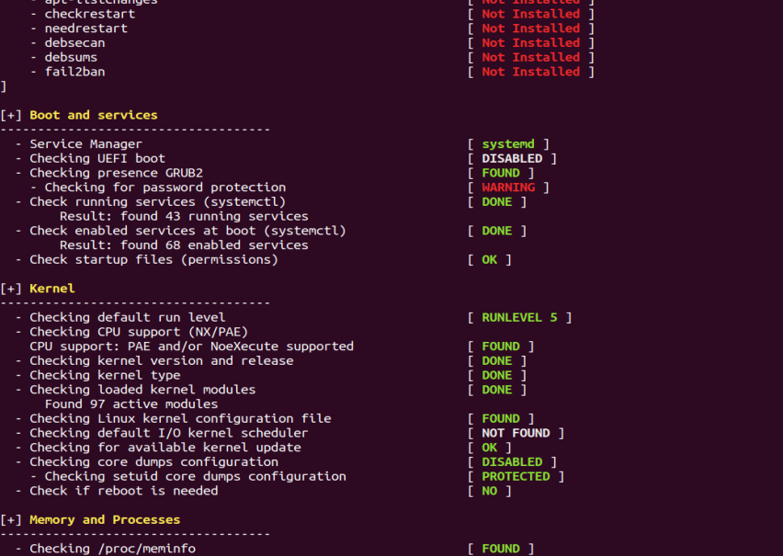

**Bonus**

1. Command to install chkrootkit:
2. Command to see documentation and instructions:
3. Command to run expert mode:
4. Provide a report from the chrootkit output on what can be done to harden the system.  
     
   * Screenshot of end of sample output: